### Build A Web Application Using Node-RED

|  |  |
| --- | --- |
| Data | 10 November 2022 |
| Team ID | PNT2022TMID27179 |
| Project Name | Smart farmer- IoT based smart farming application |

*Creating a Node-Red:*

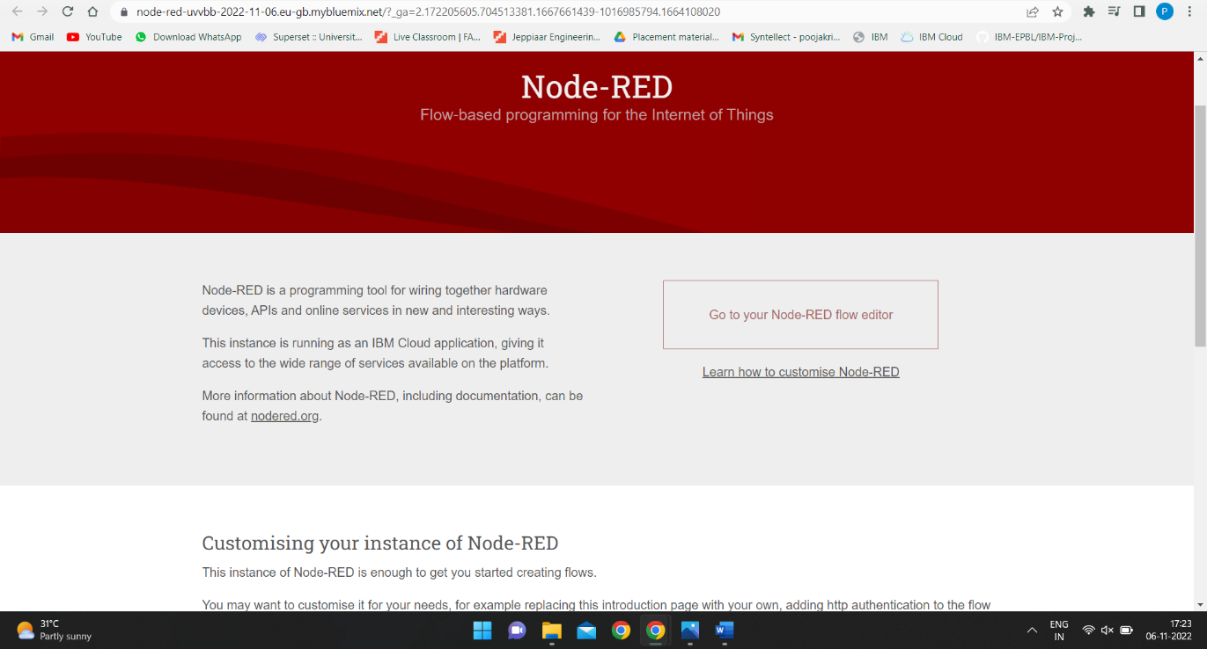

*Creating a node flow for each node:*

